**TOTAL FRAMES IN THE MINI APP**

Overall , the mini project "**Employee Management System**" , will have following frames:

**1. OptionsFrame**

**2. AddEmployeeFrame**

**3. SearchEmployeeFrame**

**4. ViewAllEmployeeFrame**

**5. UpdateEmployeeFrame**

**6. DeleteEmployeeFrame**

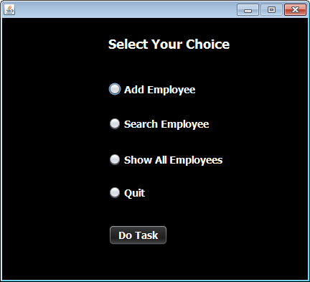

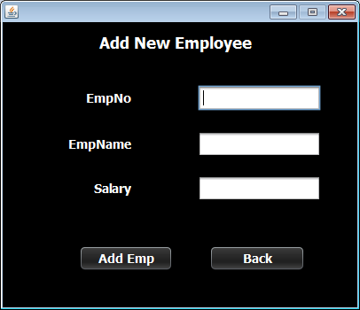

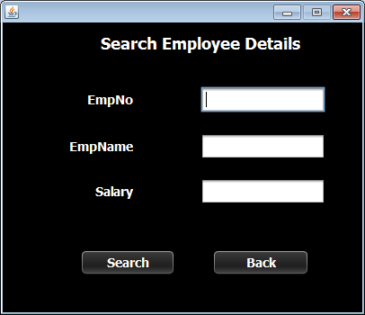

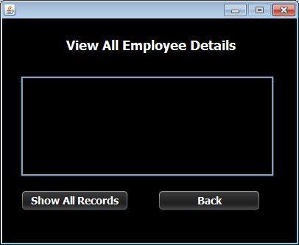

Remaining 2 frames are to be done as exercise by the student

**STEPS TO BE DONE IN** **OptionsFrame**

In the **OptionsFrame** we need to do following steps:

1. Detecting which **RadioButton** user has clicked

2. Opening the respective Frame

3. Disposing the current Frame

**DETECTING WHICH RADIOBUTTON IS SELECTED**

1. The **JRadioButton**  object has a method called **isSelected( )** which returns true if the **JRadioButton** is selected otherwise it returns false.

2. So to detect whether **jrbAddEmp** is selected or not we would write:

***if(jrbAddEmp.isSelected( ))***

***{***

***}***

**OPENING ANOTHER FRAME FROM CURRENT FRAME**

1. Create an object of the frame to be opened. For ex if you want to open **AddEmployeeFrame** then:

***AddEmployeeFrame addEmpFrame=new AddEmployeeFrame();***

2. Call the method **setVisible( )** of the Frame so that it becomes visible:

***addEmpFrame.setVisible(true);***

3. Call the method **dispose()** of current frame so that it becomes invisible:

***this.dispose();***